Notes Advanced Research Methods

# Wieringa – Chapter 1 – What is Design Science?

Every design science investigates an artifact in context by the means of two activities: designing and investigating.

* The design activity must the social context of stakeholders and goals of the project clear
* The investigative activity needs to have clear the knowledge context of the project.

## The object of study of design science

Design science is the *design and investigation of artifacts in context.* The artifacts are deisgned to interact with a problem context in order to improve something in that context (e.g. a method to improve compliance of X in Y is an artifact).



Figure 1. Example of artifact and context

Design science problems are therefore improvement problems 🡪 each of the problems has a context in which some improvement is aimed for, thus the context also has to be understood.

## Research problems in Design Science

Design and investigation correspond to two research problems: design problems and knowledge questions.

**Design problems (DP)** need a change in the real world and require an analysis of actual/hypothetical stakeholder goals. A solution is a design, and it needs to be evaluated by their utility.



**Knowledge questions (KQ)** ask for knowledge about how it the world around you, they do not need a solution. One must pay attention to not camouflage a design problems as a knowledge question.



Figure 2. How to distinguish between DP and KQ

## A framework for design science

**Problem context of an artifact:** can be extended with the stakeholders of the artifact and with the knowledge used to design the artifact. The resulting picture is a framework for design science.



**The knowledge context** consists of existing theories from data science and engineering, facts and lessons learned. The design science project uses this knowledge and can add to it creating new designs or answering knowledge questions. Prior knowledge available before the beginning of the design science project is called **posterior knowledge** (e.g. scientific literature, technical literature, Professional literature, oral communication)**.**

## Science of the middle range

The knowledge context of the design science research can be expanded by identifying different knowledge disciplines.

* **Basic science:** the study of fundamental forces and mechanisms of natures 🡪 aim at universal generalizations at the cost of idealizations which are abstraction known to be false in the real word (e.g. economics rational assumptions)
* **Case research:** the other extreme which cannot idealize from the real world and must deals with the conditions of practice. Primary aim is to help the cases it is working with directly.



The middle range sees **special sciences:** that are happy to generalize about interesting set of object but do not aim at generalizing the whole universe; **applied sciences** which apply results from other sciences but have developed knowledge of their own; **design sciences** like software engineering and information systems research. They are in the middle range because they aim at *existential generalization making realistic assumptions about their object of study –* so called**middle-range generalizations.**

On the bottom left part there are no sciences that make idealized description of individual cases, same as the top right part where there are no sciences which make universal generalization about cases without making any abstraction.

* *Our aim is to produce knowledge about the real world that does not make any unrealistic abstractions and that has a scope of validity that is as large as possible (top right corner)*

# Wieringa – Chapter 2 – Research goals and Research Questions

To frame a research project one has to specify its research goal. A design science project iterates over designing and investigating and therefore its research goal can be refined into design goals and knowledge goals. This chapter gives a template for design problems and a classification of different kinds of knowledge goals.

## Research goals

One must distinguish between the goals of the researchers to those of an external stakeholder.

Researchers will have a desire and curiosity to improve society and to do research, while the stakeholder will more likely allocate the budget to the research in order to achieve some goals and receive back useful designs and knowledge about those designs.

* For sponsors design science research projects are utility driven and budget constrained (sometimes also exploratory)
* For researches design science research projects are curiosity- and fun-driven.



Figure 3. Goal structure of a design science research project. The goals on the left concern improve- ment of the real world, and those on the right concern our beliefs about the world. In an exploratory project, there may be no higher-level improvement goals

Design science researchers often have a **prediction goal.** A prediction is a belief about what will happen in the future.

* **Knowledge goals** instead describe phenomena and explain them. To answer the knowledge questions one may have to design **instrument design goals** (lowest level deisgn goals).
* **Artifact design goals** or **technical research goal** have the objective of solving, migrating or improving some problems in the social context of the project.

**DOA example** (3)

#### The DOA project is market driven. Starting from the bottom up in Fig. 2.1, the lowest level goal was to build simulations and prototypes of DOA algorithms and of an antenna array. This is an instrument design goal. These instruments were used to answer knowledge questions about the performance of different DOA algorithms—a knowledge goal. This knowledge was generalizable and could be used to predict the performance of all implementations of the algorithm—another knowledge goal. Answering these questions also contributed to the artifact design goal of designing a DOA estimation component. This in turn contributes the goal of problem context improvement. The DOA estimation component will be part of a directional antenna for satellite TV signal reception, which is to be used in a car to allow passengers on the backseat to watch TV. The sponsor’s goal is to develop and sell components of the IT infrastructure needed for this.

## Design problems

A design problem is a problems to (re)design an artifact so that it better contributes to the achievement of some goal. Fixing the goal put us at some level in the goal hierarchy. Design problems assume a context and stakeholder goals and call for an artifact such that the interactions of help stakeholder to achieve their goals.

**Template for design problems**

1. Improve <a problem context>
2. by <(re)designing an artifact>
3. that satisfies <some requirements>
4. in order to <help stakeholders achieve some goals>.

**DOA example** (4)

1. Improve satellite TV reception in cars
2. by designing a DOA estimation algorithm
3. that satisfies accuracy and speed requirements
4. so that passengers can watch TV in the car.

Not all elements of the design problem template may be known at the start of the project! Stating the problem can help you identifying missing pieces of information that are needed to bound the research problem.

## Knowledge questions

The knowledge goals of a project should be refined into knowledge questions.

All the knowledge here are empirical questions that require data about the world to answer them. Some could also be analyitical KQ which can be answered by conceptual analysis.

One must distinguish between KQ and prediction problems. Prediction problems are about the future and we cannot *know* the future.

### **Descriptive and explanatory questions**

### **Descriptive questions:** ask for what happened without asking for explanations (journalistic) – what, where, when, who

* **Explanatory questions:** ask *why* something happened – *why*
  + Causation of event
  + Production of event
  + Reason behind event

**Open and closed questions**

* **Open question** contains no specification of its possible answers, it is exploratory
* **Closed question** contains hypotheses about its possible answers

Therefore there are 3 empirical knowledge questions:

1. **Effect questions: (**artifact * context) produce effects? E.g. what effect are produced by the interaction?
   1. What effect an artifact in a context has
2. **Trade-off questions**: (alternative artifact * context) produce effect? E.g. what effect do similar artifact produce?
   1. What is the difference between effects of different artifacts in the same context
3. **Sensitivity questions**: (artifact * alternative context) produce effect? E.g. what effect produced in different context?
   1. What is the difference between same artifacts in different context
4. **Requirements satisfaction questions**: do effects satisfy requirements? E.g. performance satisfys nonfuncitonal requirements?

# Wieringa – Chapter 3 –The Design Cycle

A design science project iterates over the activities of:

* Designing, composed of a cycle of three activities
  + Problem Investigation
  + Treatment design
  + Treatment validation
* Investigating

## The Design and Engineering Cycles

The engineering cycle is a rational problem solving process that consists of:

* Investigatin the problem (what phenomena can be improved and why?
* Treatment design: design some artifacts that could treat the problem
* Treatment implementation: treat the problem with one of the designed artifacts
* Implemtation of the evalutation: how successful was the treatment?

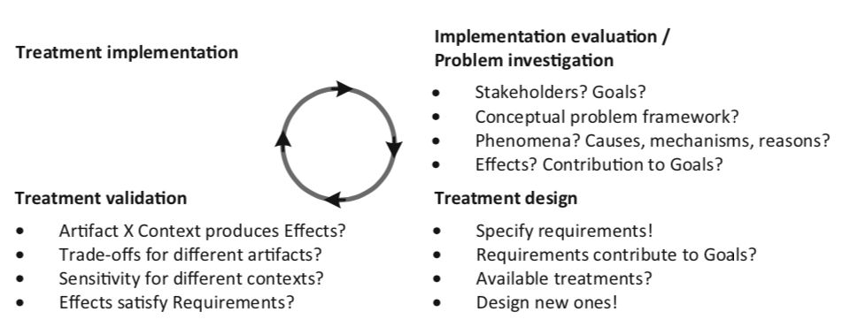

The goal of the implementation evalutation is to evaluate a treatment after it has been applied to the problem context. The goal of the problem investigation is instead to prepare for the design of a treatment by learning more about the problem.

### *Treatment*

### Avoid say designing solution because the artifact could only maybe solve partially the problem. It is therefore preferred to use the term ***interventions****.*As it suggeststhat the artifact will only interact with the context.

### ***Treatment*** here is the interaction between the artifact (the intervention) and the problem context.

### *Artifacts*

### They are used when designing, developming, implementing, maintaining information systems and software systems.

### An artifact Is something created by people for some practical purpose. It is used by people, and it interacts with a context that contains people.

### *Design and specification*

### Treatments (which are artifacts) are designed and these designs documented in a specification.

### **A design** is a decision about what to do

* **A specification** is a documentation of the design decision

*Implementation*

* **An implementation** of a treatmentis the application of the treatment to the original problem context.

An implementation is the transfer to the problem context – when we use the artifact (what we think of a solution) and we put it into working mode somewhere.

*Validation and Evaluation*

* **To validate a treatment** means justifying that would contributed (positively/negatively or just contribute?) to stakeholder goals
  + **Goal:** predicting how an artifact will interact – usually done in lab
* **Evaluating a treatment** means on the other hand investigating the treatment as applied by stakeholders in the field – done after implementation
  + **Goal:** investigating how implemented artifact interact with real world context

## Engineering Processes

The engineering and design cycles provide a logical structure of tasks but do not prescribe the process of engineering or of designing. They tells us that we have to understand, justify by validating and implementing and evaluating. They do not tell us how to manage these processes.

Possible execution sequences include:

* **Waterfall development process:** one sequential pass on engineering cycle without backtracking. Only possible if problem is understood
* **Agile development:** many sequential passes through the cycle. In each pass a problem is treated of a size small enough to pass through the entire engineering cycle
* **Scaling up:** many passes are made simplifying assumption and testing at some level of realism the artifact
* **System Engineering:** number of iterations trhough the design cycles are performed and then validated conceptually without making any implementation attempts

## Summary

* The design cycle consists of problem investigation, treatment design, and treatment validation.
* The design cycle is part of the engineering cycle, in which a designed and validated treatment is implemented in the problem context, and the implementation is evaluated.
* Implementation evaluation may be the problem investigation of a new engineering cycle.
* Managing the research and development process includes deciding what to do when, how to align with stakeholders, and how to use finite resources to achieve the research goal. This is out of scope of the engineering and design cycles.

# Wieringa – Chapter 4 – Stakeholders and Goal Analysis

Even in exploratory projects is useful to understand who are the people who could be interested in our project, the stakeholders.

**

## Stakeholders

* A person, group or institution affected by treating a problem.
* They are source of goals and constraints of the project – source for requirements in the treatment

The whole goal of the treatment design is that some stakeholders are better off when the problem is treated.

Desires and goals

There are multiple levels of awareness of a problem in which stakeholders can be:

* The first: no awareness of the problem or of the need of a treatment
* The second: awareness of an improvement possibility but no interest in carrying out the improvement
* Third: awareness of the improvement possibility and desire but not able to commit resources into realizing it
* **Stakeholder goal:** the desire for which the stakeholder has committed resources (finite)

List of possible stakeholder of an artifact

* Normal operator: give rutine commands to the artifact: end users
* Maintenance operators: interact with the system
* Operational support staff: help the system
* Functional beneficiaris: benefit from the output – user of the artfact
  + Interface the system and have an insteres
* Financial beneificiary and political beneficiary draw benefits from it
* Negative stakeholder: would be worse off when the artifact is applied
* Threat agent: wants to hust the system
* Sponsor: initiate and provides a budget
  + Purchases: terminates the development successfully
* Developers: not normal operator of the system
* Consultants and suppliers: support and deliver components of the artifact

Desires and conflicts

* 2 desires are in **logical conflict** if it is logically impossible to realize them both
* Physical conflict when there would be a violation of the laws of nature to satisfy them both
* Technical conflict when it would be physically possible to realize them but there are no technical means to achieve this
* Economic conflict: technically possible but no budget
* Legal conflict: illegal to realize them
* Moral conflict: morally wrong to realize them

# Wieringa – Chapter 5 – Implementation evaluation and problem investigation

Once treatment are implemented there may be new properties provided that could trigger a new iteration on the engineering cycle.

Research goals

* **Implementation evaluation**: evaluate an implementation of a treatment **after** it has been applied in the original problem
  + **An evaluation question**  compares an observed phenomena with a norm
* **Problem investigation:** research goal is to investigate an improvement problem **before** an artifact is designed and when no requirements have been identified yet

Theories

The goal of implementation evaluation and problem investigation is to build a scientific theory of real-world implementations and problems.

*A scientific theory is a belief about a pattern in phenomena that has survived testing against empirical facts and critical reviews by peers. It has a conceptual framework to frame the problem, describe phenomena and analyse their structure. Generalization can be useful to explain the causes or mechanisms or reasons for phenomena.*

Design science therefore is a scientific theory that studies the interaction between an artifact and its context – developing design theories. The phenomena studies in implementation evaluation and problem investigation are real-world phenomena.

Research methods

* Surveys
* Observational case studies
  + May give access to all aspects of the studied phenomena. However, they may disturb the phenomena that one is observing.
* Single-case mechanism Experiments
  + Test of a single case in which the researcher applies stimuli to the case and explains the responses in terms of mechanisms internal to the case
  + The researcher actually intervenes in the experiment
* Statistical difference making experiments
  + Apply a treatment to a sample and compare the average outcome with the average of another treatment.
  + Sample drawn at random
  + Used in implementation evaluation and problem investigation

Summary

* Implementation evaluation is the investigation of artifacts that have been trans- ferred to their intended real-world problem context. The research goal is to evaluate them with respect to actual stakeholder goals.
* Problem investigation is the investigation of real-world problems as a preparation for the design of a treatment for the problem. The research goal is to learn about stakeholder goals and to understand the problem to be treated.
* Both kinds of empirical study ask the same research questions that are about phenomena, causes and effects, and the contribution of phenomena to stakeholder goals. Questions can be open or closed and descriptive or explanatory.
* Implementation evaluation and problem investigation aim to develop theories of phenomena. A theory consists of a conceptual framework and generalizations. If the theory is about the interaction of an artifact with its context, we call it a design theory.
* Implementation evaluation and problem investigation are real-world research. Different research methods can be used, including surveys, observational case studies, single-case mechanism experiments, and statistical difference-making experiments.

# Wieringa – Chapter 6 – Requirements Specification

Think about the desired properties of a treatment before designing one.

## Requirements

# A requirement Is a property of the treatment desired by some stakeholder with committed resources

* It is a goal for the to-be-designed treatment

Contribution Arguments

* Specifying requirements is it a duty of the design researcher.
* To justify the choice of requirements one has to give a contribution argument 🡪 an argument that an artifact that satisfies the requirements would contribute to a stakeholder goal in the problem context

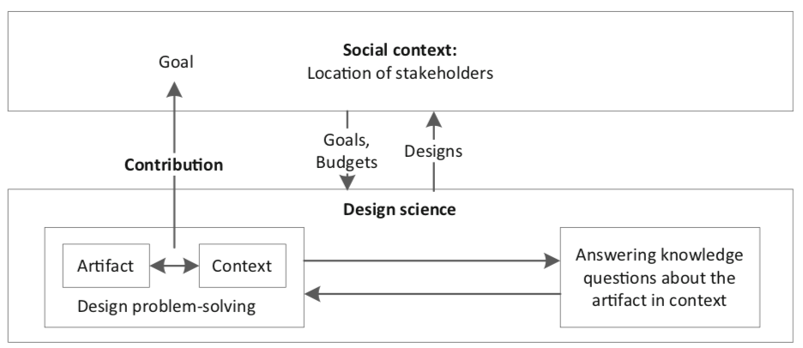

A contribution argument is a prediction because it argues that the artifact, once inserted in its problem context, would interact with it in a way that contributes to stakeholders goals.

## Kind of requirements

* Classified in different ways: according to the **importance** **of the goal** (priority) or to the **deadline** (urgency)
* Constraints on the **internal** composition of the artifact are distinguished from requirements on the **external** properties
* **Functional** and **nonfunctional** requirements
  + **Function** of an artifact is a terminating part of the interaction between an artifact and its context
  + **Nonfunctinoal property** is called also quality property and it is any property that is not a function (usually flobal properties e.g. *utility* for a stakeholder, *accuracy* of output, …)
* **Indicators and norms**
  + An **Operationalization** of a property is a measurement procedure to establish the presence of a property
    - Functional properties are operationalized by specifying tests for them
    - Nonfunctional properties are operationalized by defining one or more indicators (variables to be measured that indicate the presence of a property - metrics)
  + **Norm** for an indicator is a set of required values of the indicators (also acceptance criteria)
    - Norms operationalize requirements
    - Norms are a set of required values of the indicator (
    - Examples: “The artifact should recognize that an action happened” (ability) or “the estimation of an outcome should be less than x” (accuracy)
  + **Indicator** operationalize properties

## Summary

* Requirements are treatment goals. They are desired by some stakeholder who has committed a budget to realize them.
* Requirements are specified by the design researcher. To justify requirements, there should be a contribution argument of the form
* Requirements can be classified in many ways. One classification is the distinction
* between functional and nonfunctional requirements:
  + –  To make a nonfunctional property measurable, it must be operationalized by indicators.
  + –  To make a nonfunctional requirement measurable, it must be operationalized by indicators and norms.
  + –  Sometimes a norm is crisp, but often it just indicates the direction of improvement.

# Wieringa – Chapter 7 – Treatment Validation

To validate a treatment means justifying that it would contribute to the aforementioned stakeholder goals when implemented in the context defined.

When the requirements are defined, then we can validate the treatment by showing that it satisfies its requirements.

We want to understand and investigate how does the treatment contribute to stakeholder goals –> build validation models of the artifact in context, investigate them and build a design theory of the artifact in context to predict effect in the real world

## The validation research goal

**Goal:** develop a design theory of an artifact in context that allows us to predict what would happen if the artifact were transferred to its intended problem context.

The central problem of validation research is that is done **before implementation** so how can we investigate if an implementation in the real world does not exist?

We have to ask knowledge questions of the kind already shown in ch 2:

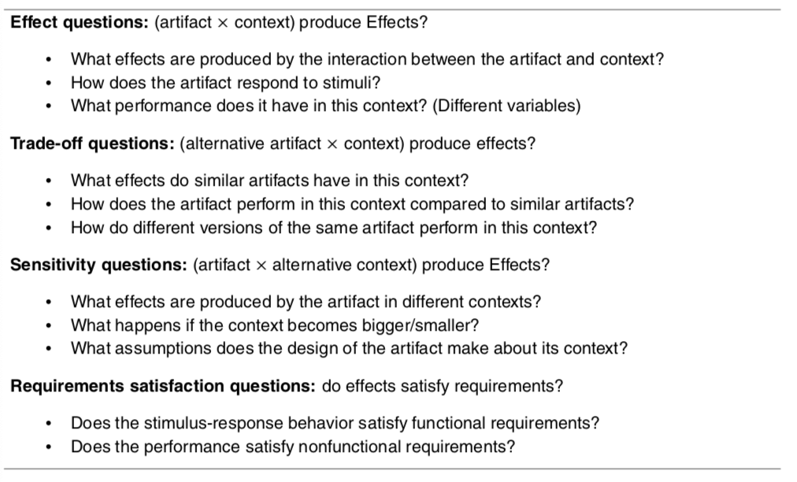

## Validation model

* **An analogic model:** is an entity that represents entities of interest, called **targets** (examples is the use of electrical network as model of a network of water pipes)
* **A validation model** consists of model of the artifact interacting with a model of the problem context (model of the artifact interacting with a model of the problem context)



## Design Theories

Once we have a theory that has successfully survived tests and criticism we use it to predict

## Research Methods

To validate models we have different methods:

* Expert Opinion: design is submitted to a panel of experts 🡪 is their requirements are not satisfied it has to be redesigned. Negative opinions are more useful than positive ones
* Single case Mechanism Experiments is a test in which the researcher applies stimuli to a validation model and explains the response in terms of mechanisms interal to the model 🡪 useful for validation research 🡪 allow us to expose the model to controlled stimuli
* Technical Action Research: use of an artifact prototype to help a client and to learn from this 🡪 usually last stage
* Statistical difference making experiment: compare the average outcome of treatments applied to sample

## Scaling up to stable regularities and robust mechanism

In the scaling up approach two lines of reasoning are followed:



* **Horizontally:** the research goal is to test an increasingly realistic model of the artifact (more practice, more real world) – case-based inference
* **Vertically:** effect exists on the average in a population. Statistic to average out the nondeterminism by observing average outcomes in samples and make plausible conclusions. **Sample-based inference**

## Summary

* In treatment validation, we develop a design theory of the interactions between the artifact and its context.
* Important validation research questions are what the effects of the interaction are and whether these satisfy requirements. Trade-off questions test the gener- alizability over different versions of the artifact; sensitivity questions test the generalizability over differences in context.
* Since we cannot, by definition, validate real-world implementations, we inves- tigate validation models. A validation model consists of a model of the artifact interacting with a model of the context.
* Research methods to investigate validation models include expert opinion, single-case mechanism experiments, technical action research, and statistical difference-making experiments:
  + Expert opinion can be used to weed out bad designs early.  
    – Statistical difference-making experiments can be used to provide empirical
* support for the existence of stable population-level average effects.  
  – Single-case mechanism experiments and technical action research can be used
* to investigate the mechanisms that produce these effects.

# Wieringa – Chapter 10 – The empirical Cycle

It is a rational way to answer scientific knowledge questions. It is structured as a checklist of issues to decide when a reseracher designs a research setups and has to reason about the data

# It is a checklist of questions that help to find justifiable answers to scientific knowledge questions, not a sequence to be performed in order.

## Research context

# 

* **(1) Knowledge goal** summarizes in one phrase all knowledge questions that you want to answer in the study
  + Typical are investigate an improvement problem
  + Survey possible treatments
  + Validate a design
  + Evaluate an implementation in the field
* **(2) Working in the context of a higher-level design or engineering cycle with an improvement goal**
* **(3) Summarize current knowledge**

## The Empirical Cycle

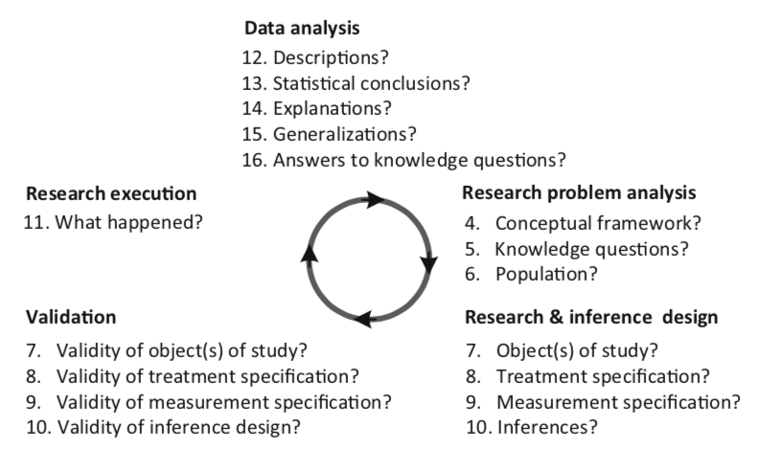

Validation in the empirical cycle is about the match between the research setup and the inferences form the data. There are three kinds of validity questions about a research design:

* *Inference support*
* *Repeatability*
* *Ethics*

## The research problem

A checklist to frame an empirical research problem

## 

## The research setup

To answer a knowledge question about a population there needs to be one or more objects of study. These have some relationship with the population.

**In case-based research:** the object of study is called a case

**In sample based research**: the researcher studies a sample of cases



**Differences**

* In case-based research we study individual objects and aim to generalize to similar object
  + Case-based uses an analytical induction process (from one case tries to generalize to the whole population
* In sample based we study samples and aim to generalize from samples
  + Studies samples as a whole and is deductive (from general to a particular theory) – uses statistical inference to draw conclusions about the population

**Experimental research vs observational research**

* **Experimental:** researcher applies an experimental treatment to the Oos and then measures what happens
* **Observational:**  reserachers refrains from intervening and measures phenomena in the Oos



## Inferences from Data

* **Inference:** is the process of drawing conclusions from data
  + **Ampliative:** conclusions may be false but premises are true
  + **Deductive:** conclusions are guaranteed to be true when premises are true
* A discussion regarding the validity, which is the degree of support of the inferences, must accompain both of them

Some categorizations:

* Descriptive inference: summarize data into descriptions, subject to constraints of descriptive validity
* Statistical inference: inference of population characteristics from sample statistics; subject to conclusion validity
* Abductive inference: most plausible explanations for observations; subject to internal validity
* Analogic inference: generalization of explanations; subject to external validity

## Execution and Data Analysis

**Oos** may interact even if no plan to do so, and there could be may more points of failure in the execution of the research. Therefore the validity of these inference designs is affected by unplanned events during research execution meaning that the validity discussion may be revisited during data analysis under the light of the new events that came up.

## The Empirical cycle is not a research process

It is only a grouping of questions and not a temporal sequence of task that must be performed. Almost anything can be changed, repeated or redone. The only two prohibited things are:

* **Rule of posterior knowledge:** knowledge created by the research is present only after execution and cannot be used before executing the research
  + **Rule of prior ignorance:** any knowledge present before the research may influence the outcome of the research.
* **Rule of full disclosure:**  all events that could have influenced research conclusions must be reported

## Summary

* In design research, we try to answer knowledge questions about implementations, problems, or treatments. The research context may be utility driven or curiosity driven.
* Empirical research is expensive, and before you attempt it, you should check other ways of answering knowledge questions, including literature study and asking experts.
* The research problem to be solved consists of a list of knowledge questions that presuppose a conceptual framework and assume a population of interest. The goal of research is to find support for a generalization to that population.
* The empirical cycle is a logical grouping of questions to ask about your research. You may also use it to decide what to put in a report and to analyze a report.
* The empirical cycle is not a list of tasks to be performed in a certain order. Almost anything goes, but two things are forbidden:
  + Rule of posterior knowledge: Knowledge created by the research is present *after* execution of the research, and it is absent before executing the research.
  + Rule of prior ignorance: Any knowledge present *before* doing the research may influence the outcome of the research.
* To ensure this, publication is required:
  + Rule of full disclosure: All events that could have influenced research conclusions must be reported.
* Research setup and inference are closely coupled, because the setup must support the inferences to be done later. Both must be designed before you start the research.

## 

# Wieringa – Chapter 16 – A Road Map of Research Methods

Design science research iterates over solving design problems and answering knowledge questions.

Design problems that need novel treatment are dealt with the design cycle

Knowledge questions that require empirical research are dealt with the empirical cycle

Design and empirical research require a theoretical knowledge in terms of a framework and generalization.

The outcome of the design cycle is a validated artifcat design but not an implementation in the context of use.

Implementation in the social context of use is transfer of technology to a stakeholder context 🡪 it is not part of design science but may be a sequel to it.

The empirical cycle goes beyond research design by executing the design and analysing the results, which are then used to answer the knowledge questions that triggered the empirical cycle.



## Four empirical Research Methods

* **Observational Case Studies:** are about individual case to investigate how the phenomena in case are produced by the architecture of the case. There is not intervention of the reseracher. Are done in the field
* **Single-case mechanism experiments:** individual cases are studied – to investigate how phenomena in the case are produced by the architecture of the case. There is researcher intervention as they are often done in the laboratory. Used and useful to validate new technology and investigating problems in the fiels
* **TAR:** reseracher experiments with single cases – not onlu to answer a knowledge question but also to help a client.
* **Statistical difference-making experiments:** two sample of population elements different treatments in order to find out if the difference in treatments causes a difference

## One checklist

Is a list of possible choices. It starts by questioning the positioning of the researcher in the goal structure of the design science project then continues with all the questions we already asked ourselves:

* **What is studied:** know which population of interests and what are its elements
* **Where is studied:** laboratory or field?
* **How it is studied:** intervene or not to intervene?
* **Why it is studied:** research goals

Possible example of this:



# Wieringa – Chapter 17 – Observational Case Studies

**An observational case study** is a study of a real-wolrd case without performing an intervention. In all forms of research the researchers tires to minimize its intervention on the case. The goeal is not to acquire knowledge about samples, but about individual cases.

These case studies are needed to study phenomena that cannot be produced in the laboratory. There are many checklists and handbooks for doing case study research in information systems.

The case study should have

* **Case study protocol**: that contains the description of the context, research problem and design
* **Case study log/ diary**:to collect details of data analysis

The checklist for the research context of observational case study:



Context

Each observational case study has a **knowledge goal** and may or may not have an **improvement goal**. If it has an improvement goal, then it is part of an implementation evaluation or problem investigation – otherwise it is a curiosity-driven study that aims to increase our knowledge about a topic.

The checklist asks about current knowledge about this topic.

Research Problem

In order to specify your knowledge questions and population of interest, one needs to define a **conceptual framework**. This should define the architectural structures that the researcher is looking for.

**Knowledge questions:** prevent you to collect too many data: these questions can be exploratory or can be focused on hypothesis testing (expectations are called propositions). Case study knowledge questions should not only be descriptive but also explanatory – case study are performed in order to gain understanding, not only facts.



A series of case studies is an example of analytical induction 🡪 using multiple studies could help improve an architectural theory and get more clarity about the population predicate.

Research Design and Validation

In observational case study research the object is cases as they are found in the real world – the study however has to be designed.

*Case selection*

This consists in the checklist for selecting a case, that are selected according to some population predicate that specifies architectural properties of the cases in the population of interest.

In case study research the population predicate may not be very clear and the goal of the research may exactly to gather more information about it.

**

For architectural inference, few consideration are relevant:

* **Analysis**: can enough information be acquired about the case architecture to analyse relevant case mechanisms
* **Variation**: most real-world cases match the population predicate but not completely
* **Abstraction**: the case architecture abstracts away components and mechanisms that may be present in real-world cases

*Sampling*

Checklist to build a sampling in the case study research

* What is the analytical induction strategy
* Validity of the sampling procedure:
  + Inference support, repeatability and ethics

*Measurement Design*

Checklist that one must go through when designing measurement in observational case study. Needs first a framework that defines variables and their scales



Inference design and Validation

Case-based inference consists of three steps: description, architectural explanation and generalization by analogy.

Descriptive inference from case data may require considerable time and effort because of the amount of data 🡪 be sure aout the resources before starting the case study.





# Wieringa – Chapter 19 – Technical Action Research

Is the use of an experimental artifact to help someone and to learn about its effects in practice. The artifact is experimental meaning that it is still under development and has not yet been transferred to the original problem context.

A TAR study is used to validate the artifact in the field

# Lecture 5

* Design and empirical cycle can be used interchangeably
* Problem investigation <-> Treatment design [in thesis pay attention, would be better to follow an agile way to keep the focus on the main topic chosen.]
* Validation
* Implementation

**Definitions**

* **Experiments:** follow research protocols
* **Treatments** are interaction between
* Treatments are deigned and the design is specified
  + Designing is deciding what to do
* **Implementation**: writing and debugging a program until it works
* **Validation**: theory level, check if our initial assumptions are reached (and at which percentage)
* **Evaluation**: reality and context, run evaluation before implementation

Design cycle and engineering cycle, main points:

* Engineering cycle is a rational decision cycle
* Problem evaluation
* Design possible treatments
* Validate them
* Implementation

# Wohlin – Chapter 2 – Empirical Strategies

There are two types of research paradigms that have different approaches to empirical studies.They should be regarded as complementary instead than competitive.

1. *Exploratory research* is concerned with studying objects in their natural setting and letting the findings emerge from the observations. This implies a Flexible research design, also qualitative research. Inductive research attempts to interpres a phenomenon based on explanation that people bring forward
2. Explanatory research is concerned with quantifying a rewlationship or compare two or more gourps with the aim to identify a cause-effect relationship. This is called fixed design study and implies that factors are fixed before the study is launched. Also called quantitative research.

## Overview of empirical strategies

3 major types of investigations:



1. **Survey:** a system for collection information from or about people to describe their knowledge attitudes and behaviors
   1. *Description:* Can be seen as snapshot of the situation to capture the current status. Could be opinion pools or market research. A questionnaire is constructed to obtain information for the research. The information is collected and then aggregated into a from that can be quantitative or qualitative
   2. *Characteristics:* never conducted to create an understanding of the sample. Survey have the ability to provide a lot of variables to evaluate. They are often needed to provide broad overviews 🡪 questions in several fields
   3. *Purposes:* 1) **Descriptive surveys** can be conducted to enable assertions about some population This could be determining the distribution of certain characteristics or attributes. 2) **Explanatory surveys** aim at making explanatory claims about the population. 3) **Explorative surveys** are used as a pre-study to a more thorough investigation to assure that important issues are not foreseen.
   4. *Data collection:* paper in person or online. In person = more answers and less “do not know”
2. **Case study:** an empirical enquiry that draws on multiple sources of evidence to investigate one instance of a phenomemnon within its real contex. It is often conducted to investigate a single entity or phenomenon. If we would like to compare two methods the study may be defined as a case study or experiment. Case studies are suitable for industrial evaluation of SE methods because they avoid scale-up problems. Difference with exepriments is that experiments sample over the variables that are being manipulated, case studies select from the variables representing the typical situation. Easier to plan and more realistic but difficult to generalize results. If the effect of a process change is very widespread a case study is more suitable .
   1. *Arrangements:* three ways: 1) comparison of the results of using the new method against a company baseline. 2) a sister project can be chosen as a baseline. The new project uses new method, sister uses old. 3) Apply method at random to some components and not to other.
   2. *Confounding factors:*necessary to minimize the effects of confounding factors – that make it impossible to distinguish the effects of the two factors from each other. Some problems: not full control of case study situation, increase in scale lead to changes in the type of problems that become most indicative.
3. **Experiment:** empirical enquiry that manipulates one factor or variable of the studied setting. Based on randomization, different tratments are applied to or by different subjects. It is launched when we want control over the situation and want to manipulate behaviour directly, precisely and systematically. The design should be made so that the object involved represent all the methods we are interested in.
   1. They may be *human-oriented* or *technology-oriented.* 
      1. *Human oriented:* humans apply different tratments to objects
      2. *Technology oriented:* humans apply different tools to objects
   2. Carrying out an experiment involves several different steps.
      1. Scoping
      2. Planning
      3. Opeartion
      4. Analysis and interpretation
      5. Presentation and package
4. **Quasi experiment:** is an empirical enquiry similar to an experiment where the assignment of treatments cannot be random but depends on the characteristics of the subjects or object themselves.

## Empirical strategies comparison

The prerequisites for an investigation limit the choice of research strategy. A com- parison of strategies can be based on a number of different factors.

* **Execution control** describes how much control the researcher has over the study. For example, in a case study, data is collected during the execution of a project.
* **Measurement control** is the degree to which the researcher can decide upon which measures to be collected, and to include or exclude during execution of the study. An example is how to collect data about requirement volatility
* **Investigation cost.** Depending on which strategy is chosen, the cost differs. This is related to, for example, the size of the investigation and the need for resources. The strategy with the lowest cost is the survey, since it does not require a large amount of resources.

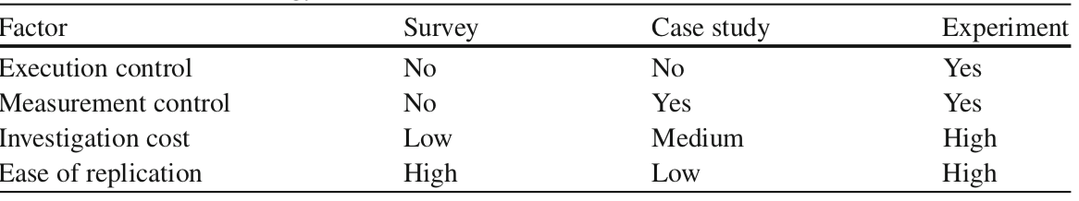

Another aspect to consider is the possibility to replicate the investigation.

## Replications

The replication involves repeating the investigation under similar conditions but varying the subject population. Replication may be of 2 different types:

1. **Close replication**: follow the original procedure as closely as possible – exact replication. Advantage is building confidence in the outcome, but often it requires the same researchers to conduct the study.
2. **Differentiated replications**: study the same research questions using different experimental procedures. It may be used for more exploratory studies.

## Theory in SE

*“A theory provides explanations and understanding in terms of basic concepts and underlying mechanisms, which constitute an important counterpart to knowledge of passing trends and their manifestation”.* There are 5 different types of theories:

1. **Analysis***:* Theories of this type describe the object of study, and include, for example, taxonomies, classifications and ontologies.
2. **Explanation***:* This type of theories explains something, for example, why something happens.
3. **Prediction***:* These theories aim at predicting what will happen, for example, in terms of mathematical or probabilistic models.
4. **Explanation and prediction***:* These theories combine types 2 and 3, and is typically what is denoted an “empirically-based theory”.
5. **Design and****action***:* Theories that describe how to do things, typically prescriptive in the form of design science.

Constructs are the entities in which the theories are expressed. Propositions are made up from proposed relationships between the constructs. The explanations originate from logical reasoning or empirical observations of the propositions. The scope of the theory defines the circumstances under which the theory is assumed to be applicable.

## Aggregating evidence from Empirical Studies

As the # of empirical studies grow aggregating evidence from multiple studies appear replication studies.

1. The research should build upon each other so to thake into consideration existing knowledge
2. Empirical studies may give an answer together but not separately, the collection must meet academic standards though

Systematic literature reviews are meant to collect and synthesize empirical evidence from different sources.

* **Primary studies**: empirical studies searched for
* **Secondary study**: systematic literature review
  + The search can be done using database queries. Snowballing means going back to the original sources of the paper found.
  + If research question is general then there may be the need of a mapping study.
* When a set of empirical studies is collected ona topic the synthesis or aggregation takes place and it is based on Statistcal methods called *meta-analysis*

## Evaluation of process changes

Objective is to discuss the strategies in terms of a suitable way of handling technology transfer from research to industrial use. The objective is to order the studies base on how they may be conducted to enable a controlled way of transferring research into practice

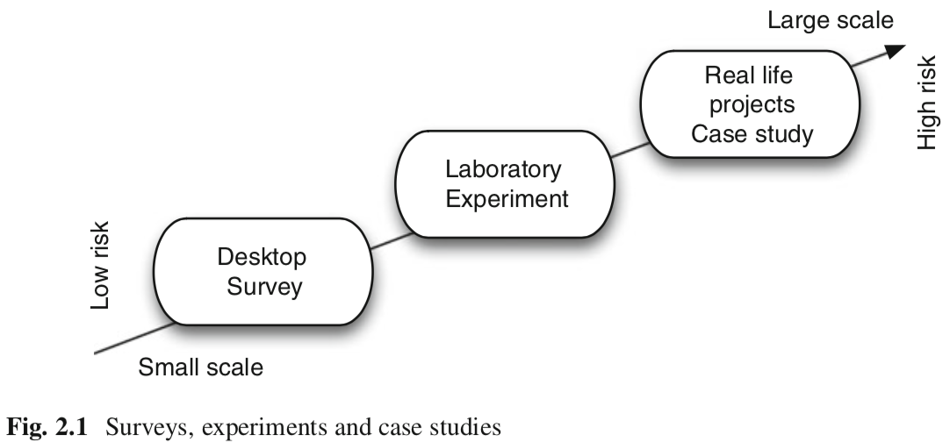

* Desktop: off-line evaluation without executing the changed process
* Laboratory: change evaluated in off-line laboratory setting In which an experiment is conducted
* Real life: real life evaluation of the change in a development situation

### *Quality Improvement Paradigm*

Is a general imporovement shceme for the software business. Based on 6 steps:

1. **Characterize**. Understand the environment based upon available models, data, intuition, etc. Establish baselines with the existing business processes in the organization and characterize their criticality.
2. **Set goals**. On the basis of the initial characterization and of the capabilities that have a strategic relevance to the organization, set quantifiable goals for successful project and organization performance and improvement.
3. **Choose process**. On the basis of the characterization of the environment and the goals that have been set, choose the appropriate processes for improvement, and supporting methods and tools, making sure that they are consistent with the goals that have been set.
4. **Execute**. Perform the product development and provide project feedback based upon the data on goal achievements that are being collected.
5. **Analyze**. At the end of each specific project, analyze the data and the information gathered to evaluate the current practices, determine problems, record findings, and make recommendations for future project improvements.
6. **Package**. Consolidate the experience gained in the form of new, or updated and refined, models and other forms of structured knowledge gained from this and prior projects.

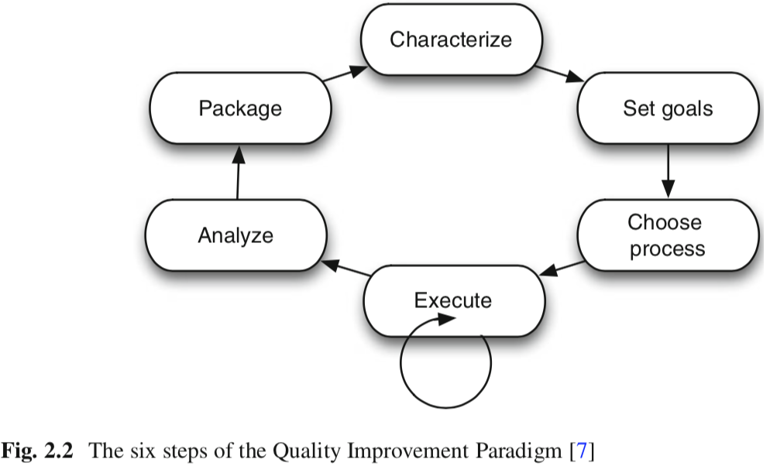

There are 2 feedback cycles: project and corporate.

The QIP is based on the improvement of software development requires continuous learning, that must be packaged into experience models that can be effectively understood and modified. These are stored in a repository called **experience base**

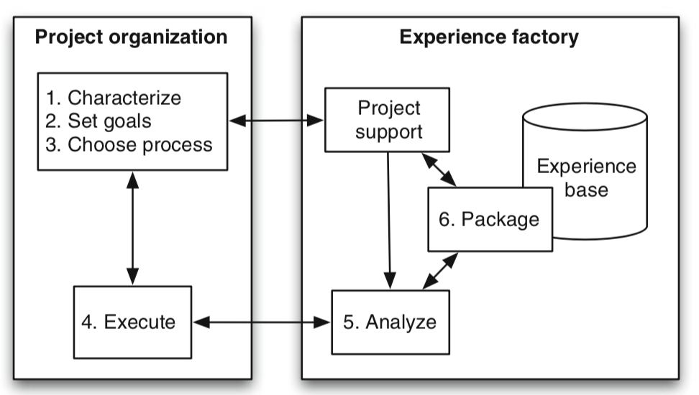

QIP focuses on a logical separation of project development from the systematic learning and packaging of reausable experience. The goal of the Experience Base is to produce and maintain software. The factory processes the information and returns direct feedback to each project with goals and models tailored from similar project.

The QIP uses a goal/question/metrics method based on the assumption that to measure the creation in a purposeful way it must:

1. Specify goals
2. Trace goals to the data
3. Provide a framework to interpreting the data

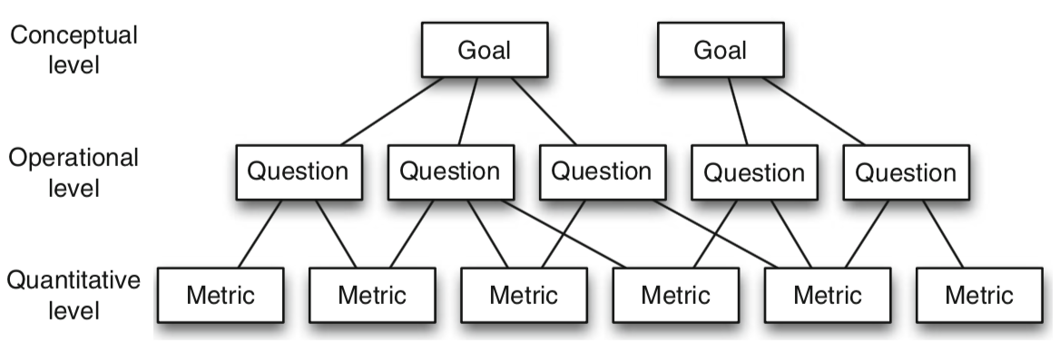

The resulting measurement model has three levels:

1. **Conceptual level**(Goal). A goal is defined for an object, for a variety of reasons, with respect to various models of quality, from various points of view, relative to a particular environment.
2. **Operational level**(Question). A set of questions is used to characterize the way the assessment/achievement of a specific goal is going to be performed based on some characterization model. Questions try to characterize the objects of measurement (product, process and resource) with respect to a selected quality aspect and to determine its quality from the selected viewpoint.
3. **Quantitative level**(Metric). A set of data is associated with every question in order to answer it in a quantitative way (either objectively or subjectively).

The following model was create in order to bring a solution to a real industrial problems using empirical methods and apply it in practice.

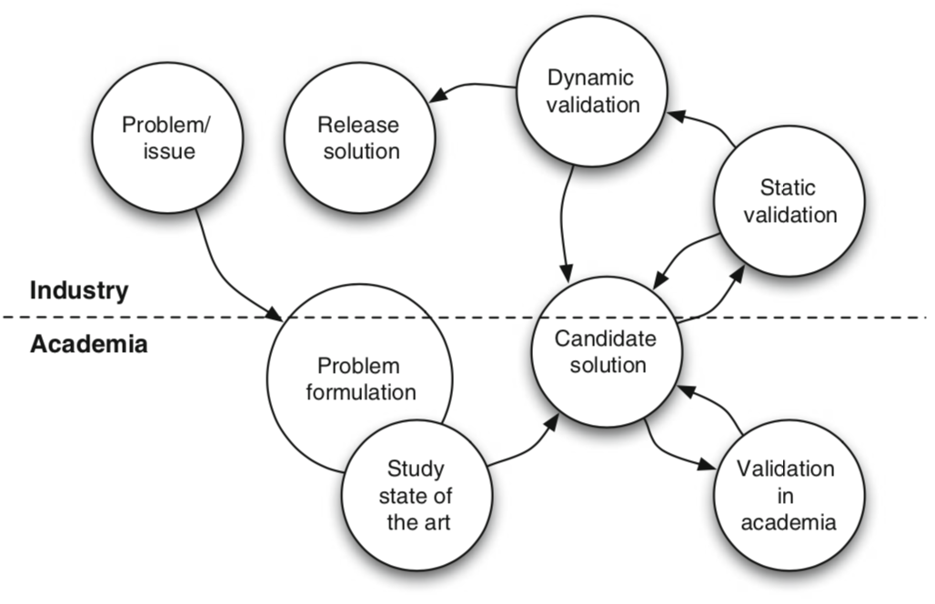

## Ethics in Experimentation

There are 4 key principles:

* Explicit consent to the pariticipation
* Scientific value of the study
* Confidentiality of the data
* Beneficience must overweight the risks

# Wohlin – Chapter 7 – Scoping

An experiment is a labor-intensive task. Therefore need a determined foundation in order to ensure that the experiment can be fulfilled.

## Scope Experiment

The scope of the experiment is set by defining its goals. The purpose of a goal definition template is to ensure the ascpects of an experiment before the execution phase takes place.

**Template:**

Analyze <object> - can be products, processes, resources, models, metrics or theories

For the purpose of <purpose> - intention of the experiment “evaluate the impact of two different techniques”

With respect to their <quality focus> - primary effect under study “effectiveness, cost, reliability, ecc”

From the point of view of the <perspective> - from which the results are interpreted

In the context of <Context> - environment in which the experiment is run



# Wohlin – Chapter 8 – Planning

While the scoping determines the foundation of the experiment – why the experiment is conducted – the planning prepares how the experiment is conducted

The planning phase can be divided into seven steps:

1. Context selection
2. Hypothesis formulation
3. Variable selection
4. Selection of subjects
5. Experiment design type
6. Instrumentation
7. Validity evaluation

## Context selection

The best option would be to execute experiment in the real world, as this is not often the case, a new method must be examined. Alternatives can be running off-line projects in parallel with the real projects, reducing the risk but costing more.



Overall the context can be characterize according to 4 dimensions:

* Off-live vs on-line
* Student vs. professional
* Toy vs. Real problems
* Specific vs. general

A common situation is that something existing is compared to something new, e.g. a method.

## Hypothesis formulation

The basis for the statistical analysis of an experiment is hypothesis testing. A hypothesis is stated formally and the data collected during the experiment is used to, if possible, reject the hypothesis.

2 hypothesis have to fomulated:

* Ho, states that there are no real underlying trends or patterns in the experiment settings: the only reasons for differences in our observations are coinicidental.
  + E.g. the new tracing method is not, on average, considered better than no method.
* Alternative hypothesis: in favor of which the null is rejected.
  + The method helps students be better in detecting changes

## Variable selection

Independent: those we can control and change in the experiment

Dependent: often one dependent variable, not directly measurable.

## Selection of subjects

* Simple random sampling
* Systematic sampling – the first subject is selected form the list of the population
* Stratified random sampling: population divided into a number of groups – random sampling is applied within the strata.

*Non probability sampling*

* Convenience sampling: the nearest and most convenient persons are selected as subjects
* Quota sampling: used to get subjects from various elements of a population

## Experiment design

An experiment consists of a series of tests of the treatments, to get the most out of the experiment, this series of tests must be planned and designed. A design of an experiment describes how the tests are organized and run

**An experiment is a set of tests**

General design principles are:

* **Randomization:** All stastitical methods used for analyzing the data require that the observations be from independent random variables. To meet this requirement, randomization is used.
* **Blocking:** often we have to block out the effect of a factor which does not interest us in the analysis. This technique increases the precision of the experiment.
* **Balancing:** assigning the treatment so that each treatment has an equal number of subjects. This simplifies and strengthens the statistical analysis of the data, but it is **not** necessary.

*Standard Design types*

* **One factor with two treatments**
  + *Completely randomized design:* we want to compare the two treatments against each other. The most common is to compare the mean of the dependent variable for each treatment.  
    Example of hypothesis is: $H_{0}: μ_{1}=μ_{2} vs. H_{1}:μ_{1}≠μ_{2}, μ_{1}<μ_{2} or μ_{1}>μ_{2},$
  + *Paired comparison design:* we can make cokmparison within matched pairs of experiment material – here each subject uses both treatments on the same object. This is called also crossover design. There is random order to each subject [PAPER ?] and the comparison for the experiment can be to see if the difference between the paired measures is zero  
    Example of hypothesis is: $δ_{j}=y_{\left\{1j\right\}}-y_{2} and μ_{d}is the mean of the difference$ $$H_{0}:μ_{d}=0 vs. H_{1}:μ_{d}≠0, μ_{d}<0 or μ_{d}>0$$
* **One factor with more than two treatments:**
* **Two factors with two treatments:**
* **More than two factors each with two treatments:**

# VS._NU – Netherlands Code of Conduct for Research Integrity – 2018–

## Principles

Research in sciences is a process governed by standards – normativity is partly methodological and partly ethical in nature and can be expressed in terms of a number of guiding principles:

* **Honesty:** reporting the research process accurately, taking alternative opinions and counterarguments seriously, being open about margins of uncertainty, etc.
* **Scrupulousness:** means using methods that are scientific or scholarly and exercising the best possible care in designing, undertaking and reporting research
* **Transparency:** ensuring that what data the research was based on is clear, how the data were obtained, how results were achieved and what role was played by external stakeholders. If part of the data is not public, there should be an account of why this happens.
* **Independence:** it means not allowing the choice of method, assessment of data, weight on alternative statements or assessment of others research or research proposal to be guided by non-scientific or non—scholarly consideration.
* **Responsibility:** it means acknowledging that a researcher does not operate in isolation and hence tales into consideration the legitimate interests of human and animal test subjects.

## Standards for good research practices

These are the principles above elaborated with more specificity to set out what researchers must take into consideration.

* **Design**
  + Consider interests of science when determining the subject and structure of research
  + Conduct scientific research of some relevance
  + Do not make unsubstantiated claims
  + Take into account lasts articles
  + Make sure to answer with the research design the research question
  + Be open about possible conflicts of interest
  + Describe how the collected research data are organized
  + Make research findings and research data public as fare as possible
  + Enter into a joint research with a partner not affiliated with the research institute only if there is an agreement of this code of conduct
* **Conduct**
  + Research has to be accurate and precise
  + Research methods have to be scientific and scholarly
  + Do not fabricate data or research results – do not remove results or data
  + Describe data collected
  + Manage the collected data carefully
  + Contribute in making data findable accessible and reusable
  + Take into consideration the interests of any humans or animals involved
  + Keep expertise up to date and research only areas that coincide with your expertise (?)
* **Reporting results**
  + Fair allocation of authorship
  + All authors must have contributed
  + All authors must have approved the final version of the project
  + Be transparent about the methods and working procedure followed
  + Be clear about results and conclusions
  + Be explicit about serious alternative insights that could be relevant
  + Cite text and research
* **Assessment and peer review**
  + Be honest
  + Do not use information acquired in the context without consent
  + Do not use the system of peer review to generate additional citations
  + Do not make assessment if not independent
* **Communication**
  + Be open and honest about your role
  + Be open and honest about potential conflicts of interest
* **Standard that are applicable to all phases of research**
  + Inclusive culture
  + Do not delay the work of other
  + Call attention to other researchers’ non-compliance
  + Make no accusation
  + Do not make improper use of research funds

# Lecture 2 – Ethics in research and Experimentation

Ethics are always expressed in *principles*. Ethics can further be subdivided into issues in

* Research
* Experimentation
* University-Industry collaboration – (always ask for informed consent)

The most wide issues in research deals with

* Fabrication of data (social psychology, antropology)
* Plagiarism (data minig, computer vision, circuit design)= appropriation of another persons’ idea, research results or words without giving credit
* Ghost-writing
* Improper dealing with infringement of integrity

Problem with lack of ethics standard is ruining careers of all the researchers related to the person who breaks the ethic’s code.

There are two ways of committing ethics issues when dealing with data:

* **Falsification:** removing or moving data
* **Fabrication**: creating new data points

It is important to restate that research institutes have the duty to promote good research management